Vinny Chhan GA2908

Team: Flipbook

CSC 4111 Software Engineering Lab sec 001

April 15, 2020

Assignment 6 Unit Testing

For this assignment I tested the six main functionalities of the main page; the navigation on the header, the category function, the search bar, the contact link, and the return home function associated to the logo. I have disabled a few functions so that I may test only the functionality of the aforementioned and not the functionality as a whole. I am only testing the validity of the function. By disabling most of the functions of the other pages, I will not have many notable changes but they are still there.

Method: I ran the website and tested the functionality on a browser. I used a functionality test as an end user.

Github repository: https://github.com/WSU-4110/flip-book.git

Testing the contact banner, works; no errors

Connecting to the cart from the home page works, no errors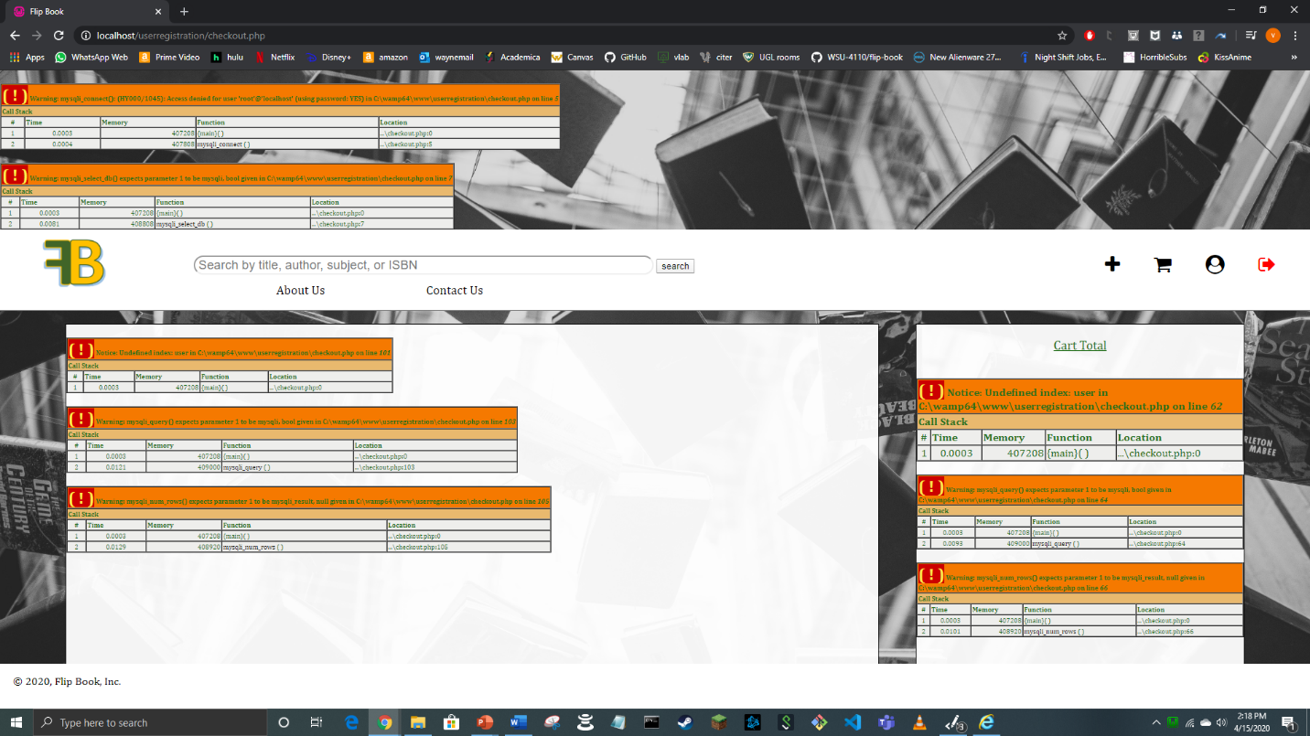

The profile banner connects no errors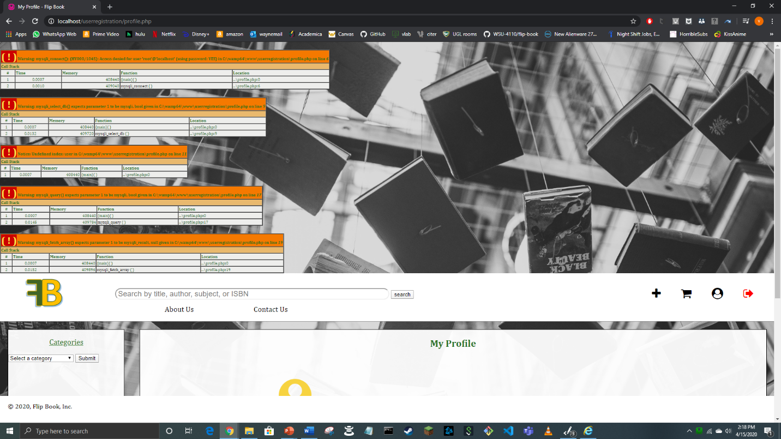

The flipbook logo redirects back to the home page, no errors occur

The about us banner connects to the correct page and loads without error

As you can see the pages load properly but some do not function because I disabled their functions to test only the home page.